**Judgment upon Mankind**

Revelation 9:12-21   
June 7th, 2017

**I. The Request from the Golden Altar — verses 13-14**

1. Old Testament Tabernacle
2. There is a request — a prayer — verse 13

**II. The Release of the Four Angels — verses 15-19**

A. What kind of angels — verse 15

B. Why the River Euphrates

1. By the River Euphrates — Adam and Eve sinned
2. By the River Euphrates — the first murder was committed
3. By the River Euphrates — the first grave was dug
4. By the River Euphrates — the Tower of Babel was built
5. By the River Euphrates — the enemies of Israel were located

C. Startling announcement — verse 16

**III. The Response of Man — verses 20-21**

1. You would think that man would repent — verse 20
2. Note their sins — verse 21

ISRAEL ABIDING IN THEIR TENTS IN THE PLAINS OF MOAB—

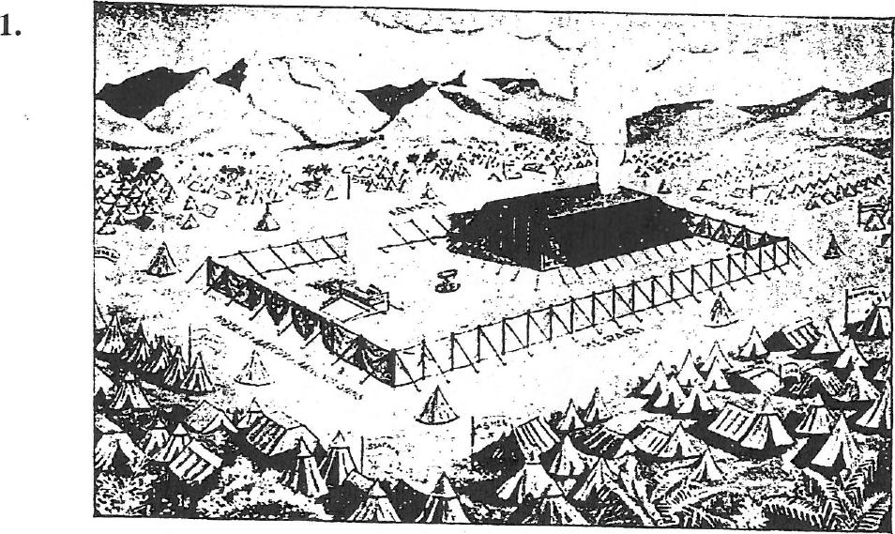

1.

**NUMBERS XXII** and xxxn

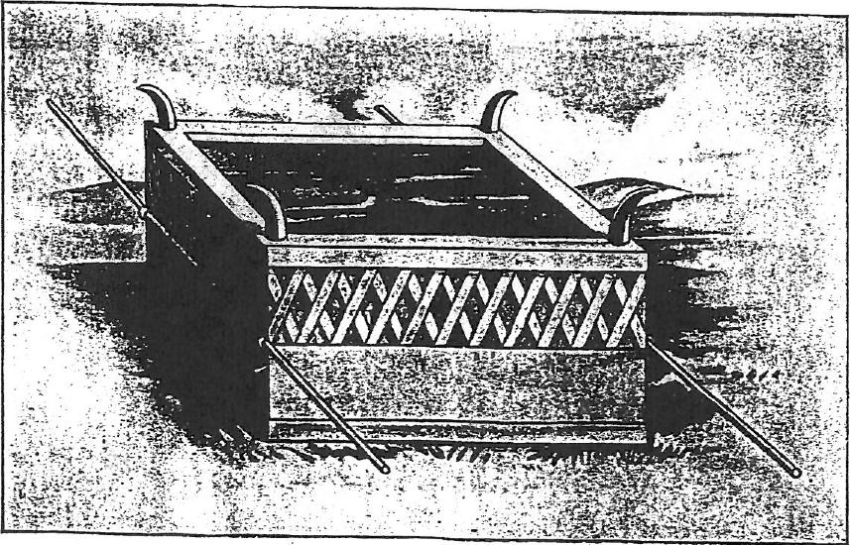

THE BRAZEN ALTAR, OR ALTAR OF BURNT OFFERING—EXODUS xxvn

|  |  |
| --- | --- |
|  |  |
|  | THE ARK AND MERCY SEAT-EXODUS xxv, 10 |

|  |  |
| --- | --- |
|  |  |
|  | THE HOLY PLACE-EXODUS xi., 22-27 |